Ward 5 eblast
Saturday, August 22, 2026
The Mississippi Emergency Management Agency opened five Disaster Service Centers this past Tuesday, August 18. The centers will serve residents who experienced damage during Tropical Storm Arthur on June 18-20. The Donal Snyder Community Center location, 2520 Pass Road, Biloxi, is open Monday – Friday, 8:00 am to 6:00 pm to assist residents with applications
Councilman, Ward 5
228.297.6800
ptisdale1@yahoo.com
www.tisdaleforbiloxi.com
Public meetings this week...
Develop Rev Committee (DRC)
Architect. & Historical Commission
166 Balmoral Ave, replace fence boards
City Council
Bits & Pieces…
Tailgate downtown, August 22
B-Connect… see it, report it
Docket… It’s your money!
Traffic notes & street sweeping
City job postings
Weekly department reports
BTV, watch online
Who to contact for...
City complaints or concerns
bconnect@biloxi.ms.us or
228.435.6271
Trash or garbage issues?
Dial 228.701.9086
Press 1 Waste Management
(garbage)
Press 2 Pelican Waste (trash)
Water, Sewer, Gas, or Drainage
emergency after working hours?
Call Dispatch: 228.392.0641
Streetlight issues, Ward 5,
Call MS Power: 1.800.487.3275
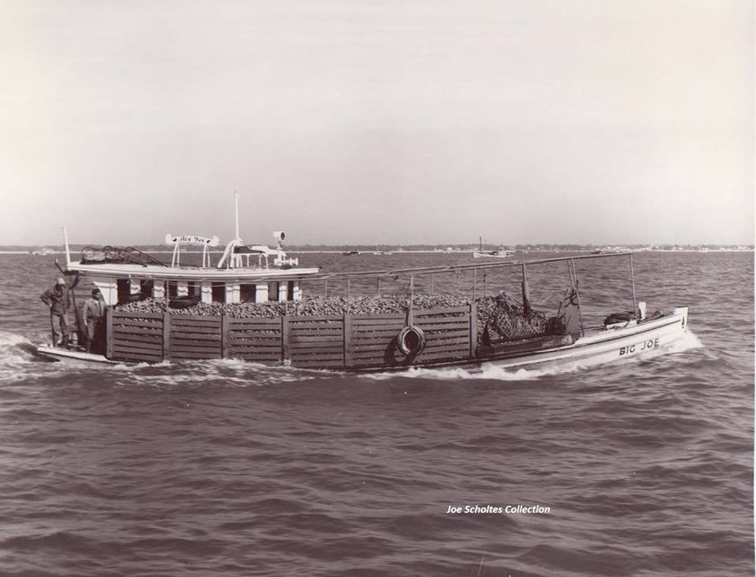
Big Joe, oyster boat, Biloxi, date unknown (Joe Scholtes Collection)
Paul
► The next Council meeting is Tuesday, August 25, 1:30 pm Agenda
Of particular interest...
1) 3A Public Hearing to consider an appeal to reverse an AHRC decision
2) 4A Amend Sec. 23-43-(d)(9)(e), pertaining to Auto Wrecker Service
3) 4B Resolution to deny the appeal and affirm the AHRC decision
4) 4E Resolution appointing the City of Biloxi Municipal Clerk
5) 5C Resolution authorizing emergency repair of Bay Vista Water Well
6) 5F Professional Services Agreement, non-communicating water meters
7) 5H Authorize Colonial Life and Accident to administer Cafeteria Plan
8) 5I 5J 5K 5L Authorize benefits to be offered to employees
9) 5M Authorize Met Life to provide employees with vision insurance benefits
10) 5N Resolution authorizing self-funded employee group health insurance
►A Budget Workshop will immediately follow this Council meeting.
► This week’s council video is unavailable due to technical difficulties.
Council comments are unavailable due to the same technical difficulties.
► To see Council action on individual agenda items click here
► To see the Budget workshop that followed the Council meeting, click here

Biloxi Sports Hall of Fame... More on each inductee in BNews, pp 8-9
The public is cordially invited to attend the 2026 Biloxi Sports Hall of Fame induction ceremony. Inductees will be recognized and honored Sunday, August 30, 2026, 3:00 pm, at Biloxi Civic Center, 578 Howard Avenue. Casual attire; dinner will be provided. This year’s inductees are:
Jesse Ratliff Felicia Burton Tommy Hebert Sean Miller Ronald Dupree Kaylee Elder Johnson Jeffrey Breal Gerald Pickich Richard Dick, Sr. Reginald Kemp Tommy Thompson Joshua Bozeman
1989 Biloxi High School Basketball State Champions
1972 Biloxi Southern Little League Mississippi State Champions
1969 Biloxi American Little League Mississippi State Champions

